Weekly reports are to be emailed to atbecker@uh.edu by 5:00pm on Tuesdays. The purpose of a weekly report is to: (1) give you text and images for your papers, thesis, and dissertation, (2) document progress, (3) identify if you are stuck or need resources.

Weekly report

1. **My *Goals* from last week**

* Make a 1 foot by 2 foot tilt table.
* Alter magnetic sliders so the same pole sliders don’t repel each other too much.
* Test out a 3D printed slider.

1. **My *Accomplishments* this week**
   1. Project 1: <1’x 2’ Tilt Table>

* DWG file of the board.

[*https://github.com/aabecker/LaserCutter3DPrinter/blob/master/LaserCutter/Designs/Jarrett%20Lonsford/1ft_by_2ft_Tilt_Table.dwg*](https://github.com/aabecker/LaserCutter3DPrinter/blob/master/LaserCutter/Designs/Jarrett%20Lonsford/1ft_by_2ft_Tilt_Table.dwg)

* The large tilt table took approximately eleven hours split over two days to cut from the laser cutter. It took about an hour and a half to draw initially (as the many lines made AutoCAD run very slow) and then another half hour to edit the drawing so that the incomplete cut would continue exactly where I left off. I managed to match up the two cuts fairly well, the second cut was just about a half millimeter further to the right but this discrepancy can easily be sanded out. This table should be large enough to make a parts bin demonstration and I will assemble that once I have made more stop blocks.

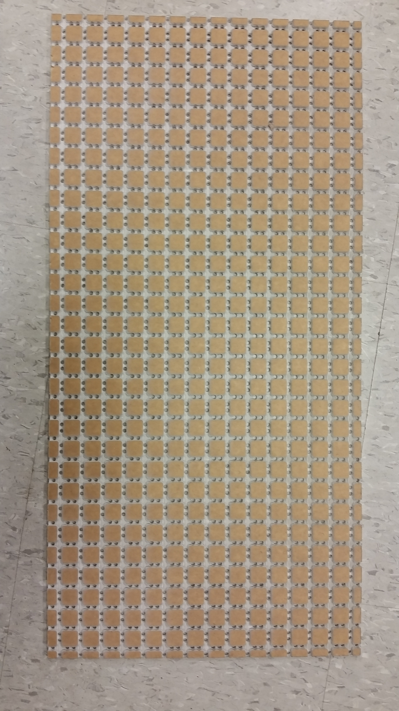

**Figure 1:** One foot by two foot tilt table, fresh off the laser cutter.

* 1. Project 2: <Magnetic Sliders>
     + DWG files for the fourth version of magnetic sliders. <https://github.com/aabecker/LaserCutter3DPrinter/blob/master/LaserCutter/Designs/Jarrett%20Lonsford/Magnetic_Slider_V4.dwg>
     + Slider version 4 is a circular slider with eight magnets, but every other magnet is closer to the center of the slider to reduce the repulsion force while still preventing sliders with the same polarity from sticking together. These sliders work very well and thus far the only issue with them is that they are time consuming to make. When making these sliders the magnets often don’t want to go into place when other magnets are nearby, sometimes they will come flying out towards each other if knocked loose prior to being glued in, and the gluing process can be long and messy. After being glued the sliders must also be left out overnight so that the glue dries properly without leaving a white film on everything in the immediate vicinity. Other than the annoyance of assembly, these sliders are fine, they do what they are supposed to and should work well for the parts bin demonstration.

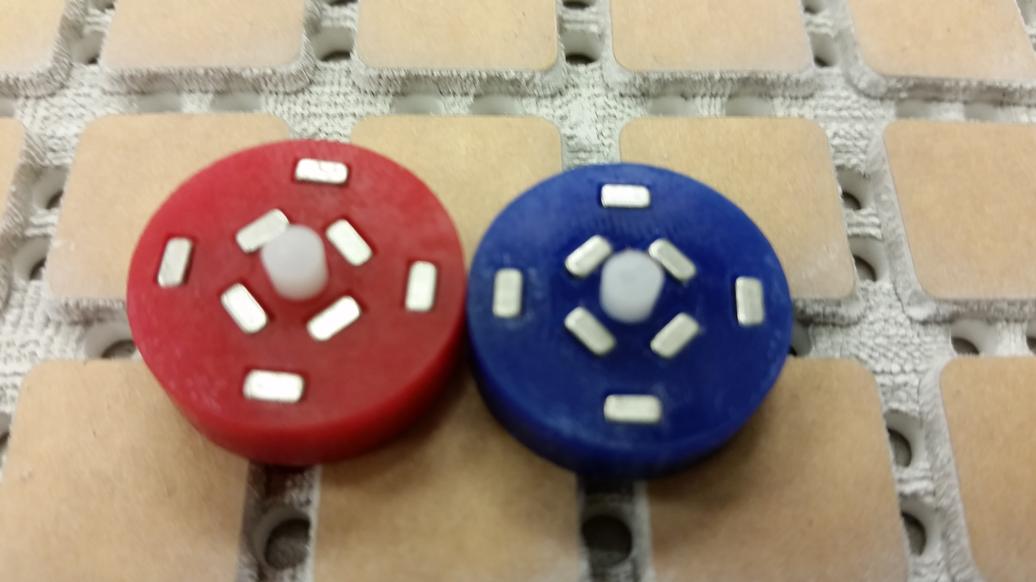

**Figure 2:** 2 Version 4 Magnetic Sliders of opposite polarity.

* 1. Project 3: <3D Printed Sliders>
* STL file for Passive Slider Version 2 made from the 3D Printer

<https://github.com/aabecker/LaserCutter3DPrinter/blob/master/3Dprinter/Jarrett%20Lonsford/Slider_V2.stl>

* In order to possibly avoid the lengthy process of sanding the laser cut sliders so that they work smoothly with the tilt table, I attempted to make a slider from the 3D printer that would require less extra work. While these new sliders work fairly well, about as well as the first version of passive sliders, they require a little less work but possibly a little more time. It takes about thirty minutes to 3D print one slider and then it must also be melted a small amount with the blow torch on the bottom surface to make it smoother. While these sliders may be a good alternate solution they can easily be messed up during the blow torch process and then there’s thirty minutes down the drain. I haven’t yet decided which sliders are the best to use going forward.

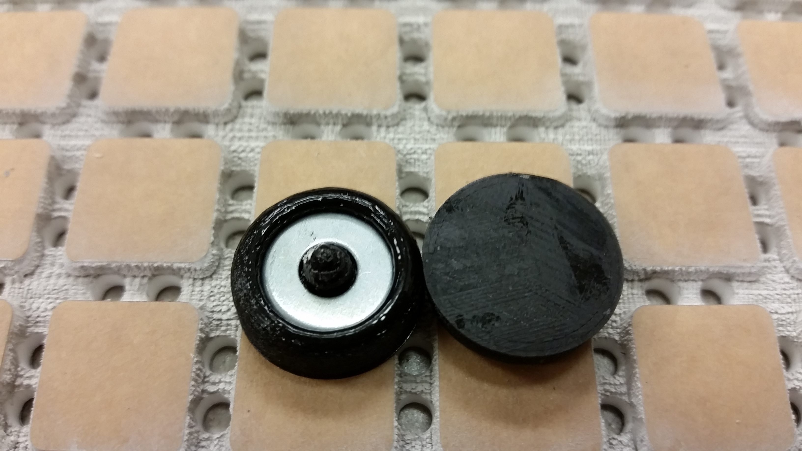

**Figure 3**: Passive Sliders Version 2, bottom and top views.

1. **My *Goals* for next week**

* Make more version 4 magnetic sliders.
* Make more stop blocks.
* Begin assembling a parts bin layout.
* Test the servo stand with the large tilt table.
* Decide which passive sliders are best.

1. **What I need Dr. Becker to do:**

Time Sheet: (Zoom in to read)



Notes: This week I had to catch up on school work from RSS so my hours are wonky.